USER INTERFACE AND DESIGN

Experiment -4

ROLL NO:240701007 NAME: ABINASH G
Create a prototype with familiar and unfamiliar navigation elements. Evaluate ease of use with different user groups using proto.io

Screen 1:
Screen 1 is the Sign In page of the PlayStation destination app.

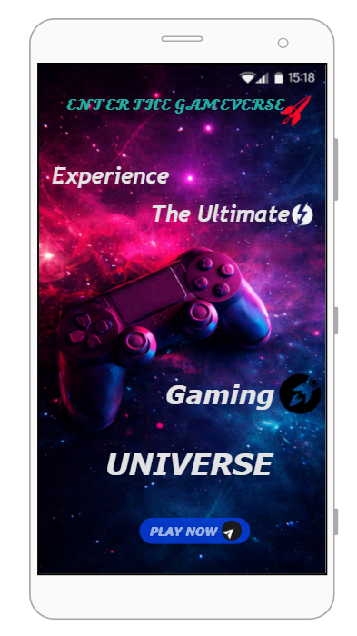

Screen 2:
Home page:
Familiar Icons
- Hamburger Menu (☰) – Top Left
  - A commonly used icon representing the main navigation menu.
  - Clicking this icon opens a sidebar menu with options such as:
    - My Games
    - Purchases
    - Favourites
    - Settings
    - Log Out
- Search Icon (🔍) – Below the Heading
  - A universally recognized icon for searching content.
  - Clicking it allows users to search for games by name or category.
- Three-Dot Menu (⋮) – Near “Trending Games”
  - Represents additional options related to the Trending Games section.
  - Can be used for actions like:
    - Sorting games
    - Filtering content
    - Viewing more options

Possibly Unfamiliar Icons:

Explore Button

A call-to-action button used to explore available games.

Clicking Explore navigates the user to the Games Listing / Swipe Screen.

From there, users can swipe between multiple games.

Trending Games Section

Displays popular and recommended games.

Shows a highlighted game card with:

Game image

Platform (PS5)

Mode (Single Player)

Swipe Arrows (◀ ▶)

Allows users to swipe between different game cards.

Used to browse multiple games one by one.

Time Display (Top Right Corner)

Standard mobile device status indicator.

Shows the current time and system status.

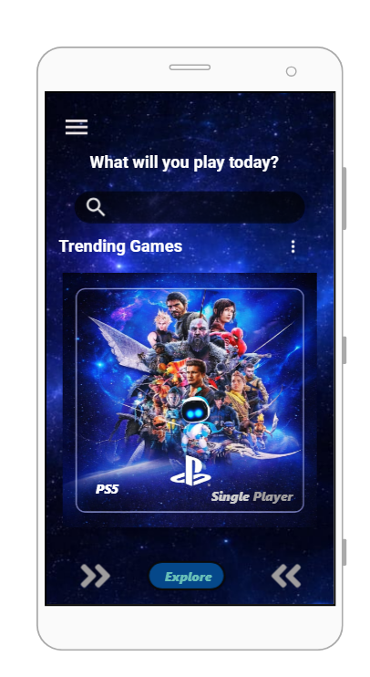

Screen3:
Game 1 page:

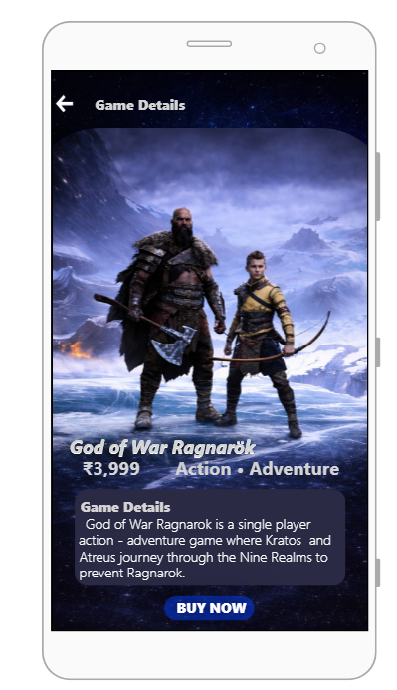

Screen4:
Game 2 Page:
Familiar Icons
- Back Arrow (←) – Top Left Corner
  - A widely recognized navigation icon.
  - Clicking this arrow takes the user back to the previous screen (Explore / Game listing screen).
  - Helps users easily return without losing their browsing flow.

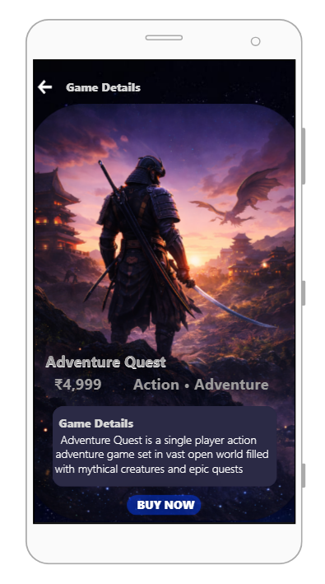

Screen 5:
Game 3 Page:
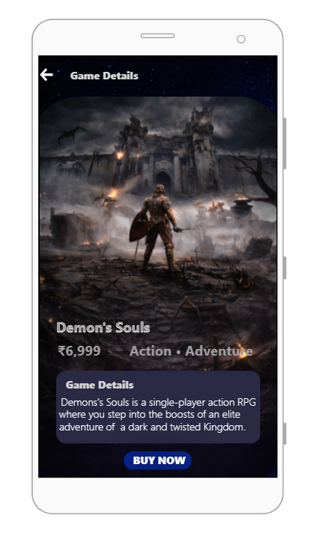
Familiar Icons
- Back Arrow (←) – Top Left Corner
  - A widely recognized navigation icon.
  - Clicking this arrow takes the user back to the previous screen (Explore / Game listing screen).
  - Helps users easily return without losing their browsing flow.
Screen 6: Profile page:

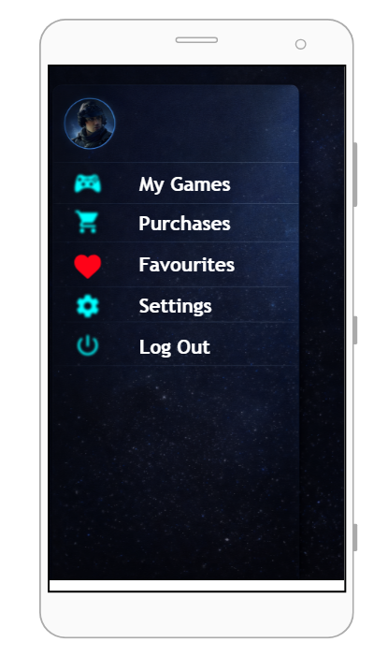

Familiar Icons:

1. Profile Icon (Circular Avatar – Top Left)

Represents the user’s profile picture or avatar.

Clicking this icon allows the user to:

View profile details

Edit profile information

Helps personalize the app experience.

2. My Games Icon (🎮) – Next to “My Games”

Commonly used to represent owned or installed games.

Clicking this option navigates the user to:

A screen showing all games the user owns or has installed.

3. Purchases Icon (🛒 / 💳) – Next to “Purchases”

Represents purchased items or transaction history.

Clicking this option opens:

A list of games the user has bought

Purchase details such as price and date.

4. Favourites Icon (❤️) – Next to “Favourites”

A universally recognized icon for liked or saved items.

Clicking this option navigates the user to:

A screen displaying only the games marked as favourites (hearted games).

Only games with the heart icon selected will appear here.

5. Settings Icon (⚙️) – Next to “Settings”

Represents application settings and preferences.

Clicking this option opens:

Account settings

App preferences

Notification and display options.

6. Log Out Icon (⏻) – Next to “Log Out”

Commonly represents signing out of the application.

Clicking this option will:

Log the user out

Redirect the user back to the Sign In screen (Screen 1).

Screen 7: Booking page: Familiar Icons:

1. Back Arrow (←) – Top Left Corner
- A universally recognized navigation icon.
- Clicking this arrow will:
  - Take the user back to the previous screen (Game Details / Explore screen).

Screen Elements & Functions
2. Game Title & Price
- Game Name: God of War Ragnarök
- Price: ₹3,999
- Clearly shows the selected game and its cost to avoid confusion.

3. Game Banner Image
- Displays a high-quality visual of the game.
- Helps users confirm they are purchasing the correct game.

4. Edition Selection
- Options available:
  - Standard
  - Deluxe
- User can select only one edition at a time.
- Selected edition will be:
  - Highlighted visually (active state).

5. Access Type Selection
- Options available:
  - Single Player
  - Online / DLC
- Helps users understand what type of access they will receive.
- Selected access option will:
  - Be highlighted when clicked.

6. Platform Information
- PS5
- Indicates the supported platform for the selected game.

7. Proceed Button
- Primary call-to-action button.
- Clicking Proceed will:
  - Navigate the user to the Payment Confirmation screen for this specific game.

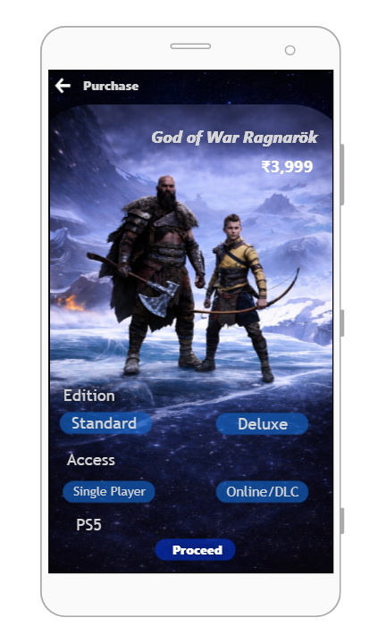

Screen 8:
Confirmation page:

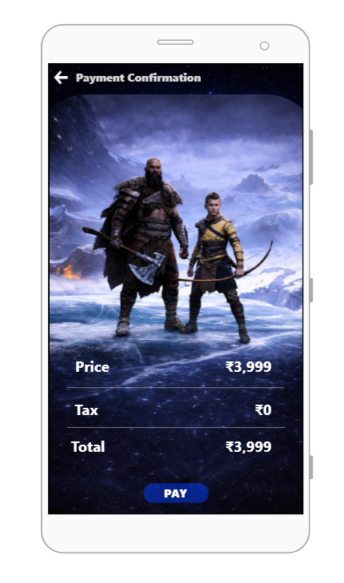

Familiar Icons:

1. Back Arrow (←) – Top Left Corner

- A common navigation icon used in almost all mobile apps.
- Clicking this arrow will:
Take the user back to the previous Purchase screen (Edition & Access selection).

Screen Elements & Functions

2. Game Banner Image
- Displays the selected game (God of War Ragnarök).
- Helps the user visually confirm the game before payment.

3. Price Details Section
- Price: ₹3,999
- Tax: ₹0
- Total: ₹3,999
- Shows a clear cost breakdown for transparency.

4. Pay Button (CTA) – Bottom Center
- A standard call-to-action button used for confirming transactions.
- Clicking Pay will:
  - Navigate the user to the Payment Successful screen.

Screen 9:

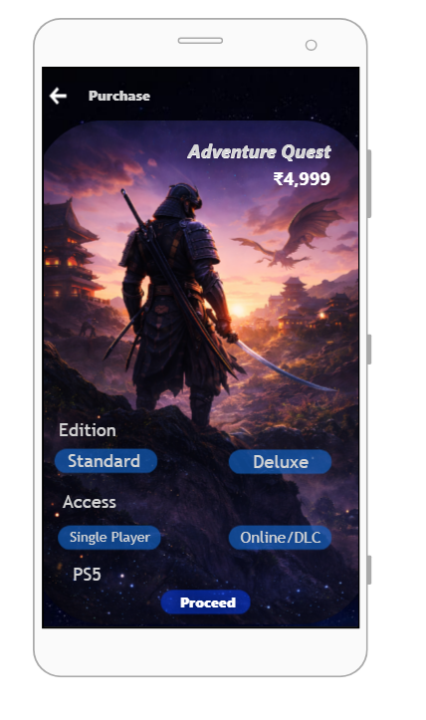

Screen 10:

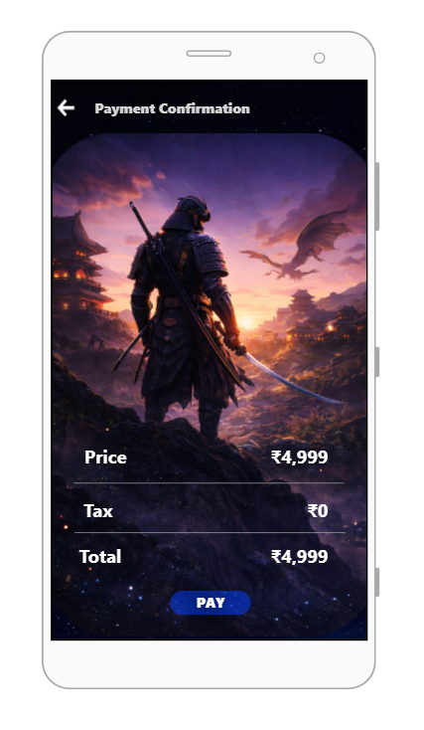

Screen 11:

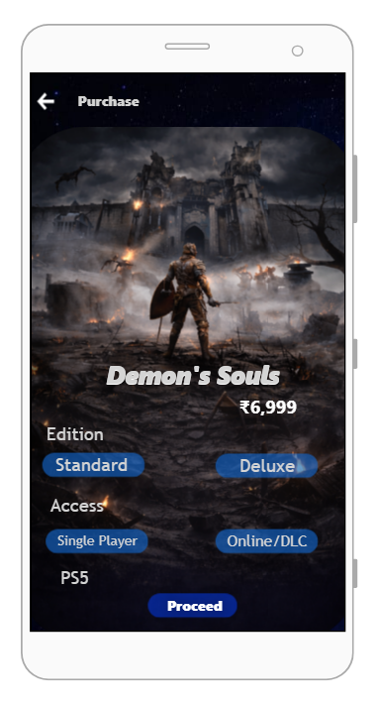

Screen 12:

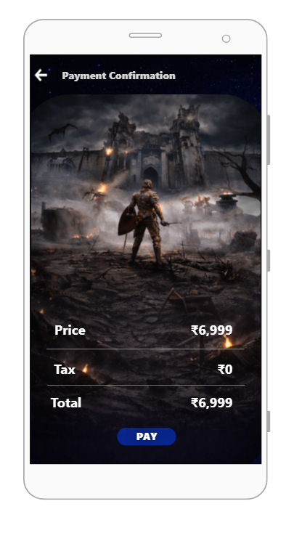
Screen 13:

Payment confirmation Page:

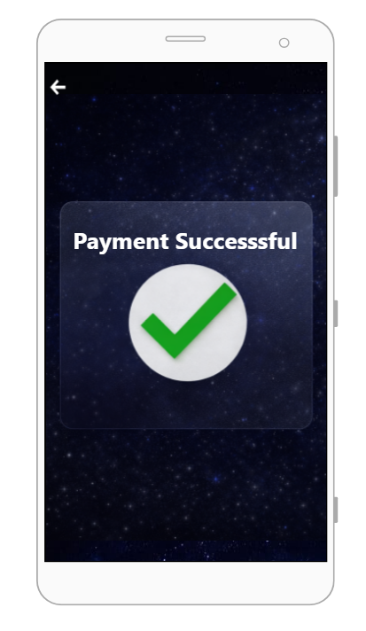

Prototype Link: https://pr.to/RAAOS2/

